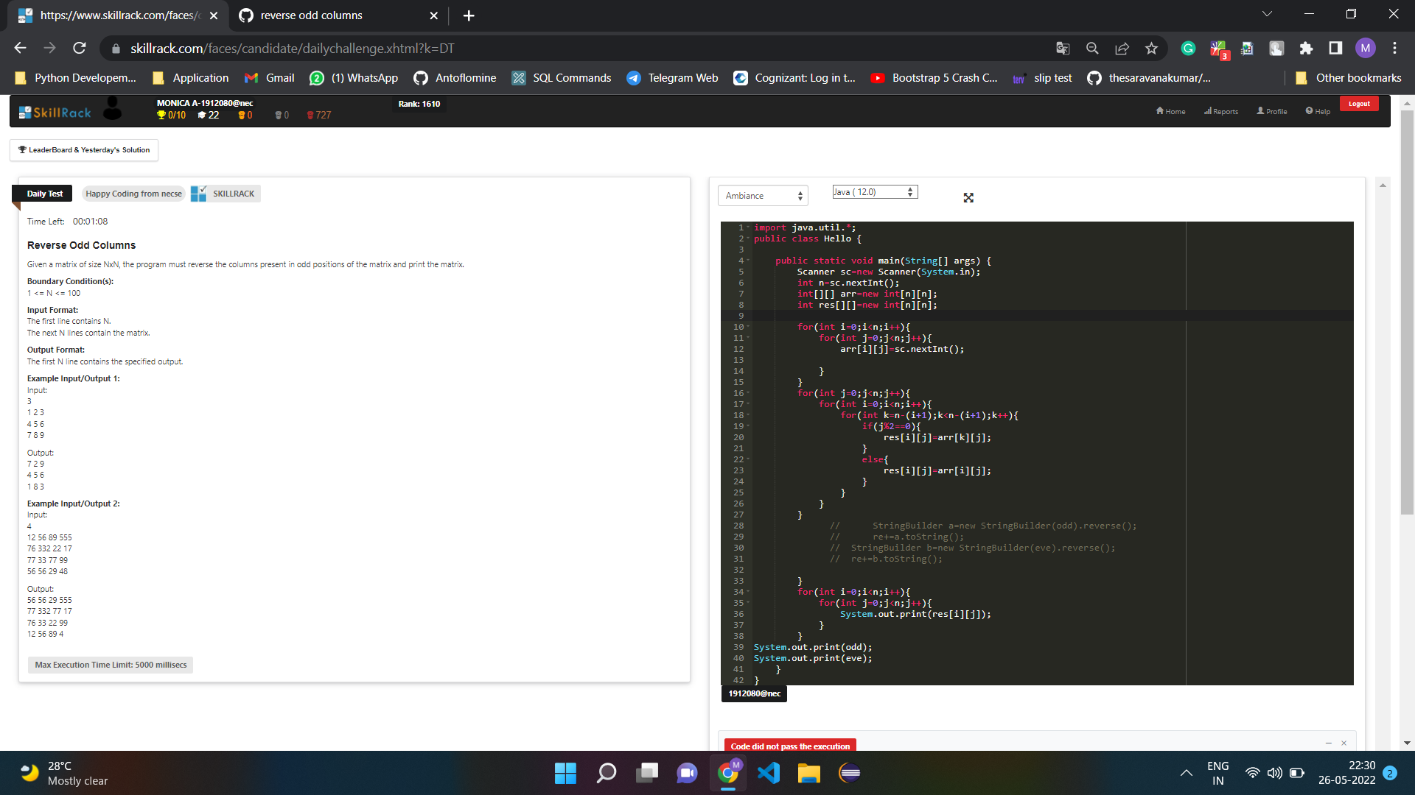

import java.util.\*;

public class Main{

public static void main(String[] args) {

Scanner sc=new Scanner(System.in);

int n=sc.nextInt();

int[][] arr=new int[n][n];

int res[][]=new int[n][n];

for(int i=0;i<n;i++){

for(int j=0;j<n;j++){

arr[i][j]=sc.nextInt();

}

}

for(int j=0;j<n;j++){ //0

for(int i=0;i<n;i++){ //0 //1 //2

for(int k=n-(i+1);k<=n-(i+1);k++){ // 3-(0+1)=2 //3-2=1 //3-3=0

if(j%2==0){

res[i][j]=arr[k][j]; //20 //10 //00

}

else{

res[i][j]=arr[i][j];

}

}

}

}

for(int i=0;i<n;i++){

for(int j=0;j<n;j++){

System.out.print(res[i][j]+" ");

}

System.out.println();

}

}

}te